HealthConnect Experience Lab

Week 5 Initial Analytics Report

1. INTRODUCTION
HealthConnect Clinic is a fictional healthcare provider looking to improve how many patients actually show up for their appointments, cut down on missed slots, and make better use of the appointments it has available — all through data-driven decisions rather than guesswork.
This report picks up where Week 4 left off and puts that groundwork into practice. The focus here is on digging into what's actually driving attendance and no-shows, through exploratory analysis, a set of KPIs, and a dashboard to bring it all together.

2. WEEK 4 RECAP

The Business Problem
HealthConnect has been dealing with a lot of missed appointments and that comes with real costs like wasted clinical resources, extra admin work, and patients not getting the care they need on time. This project sets out to understand why appointments get missed and where there might be room to fix that.

Recap
Week 4 was mostly about getting to know the dataset, understanding its structure, checking its quality, and figuring out what questions were worth asking. From there, we sketched out some possible KPIs and a rough plan for how to approach the analysis going forward.

3. DATA PREPARATION, REVISITED
Before diving into the analysis, it was worth double-checking the prep work from Week 4.
Here's what was reviewed:
- Data types were verified.
- Missing values were checked.
- The data was scanned for duplicate records.
- Any inconsistent values were flagged.
- Variables were confirmed as fit for purpose.
The original dataset was left untouched throughout and all exploration was done on a working copy, just to be safe.
A few things stood out:
- Around 27% of records were missing a value for the reminder channel.
- Waiting time and distance to clinic were missing in under 2% of records.
- No meaningful duplicate issues turned up.

4. EXPLORATORY DATA ANALYSIS
The next step was exploring what factors might actually be influencing whether patients show up.
This included looking at:
- Appointment outcomes
- Appointment types
- Patient demographics
- History of previous no-shows
- Whether a reminder was sent
- How far in advance the appointment was booked
- Waiting time
- Distance to the clinic
A number of visualisations were built in Python to get a feel for how these variables were distributed and how they related to whether someone attended or not.
Those findings were then pulled together into an interactive Power BI dashboard.

5. BUILDING THE KPIS
Five KPIs came out of this stage, each aimed at capturing a different angle on clinic performance.
Prior to creating the DAX measures for the KPI calculations, I created a few Measures that I would use to guide me through the KPI calculations:
Total Appointments = COUNTROWS('HealthConnect_Appointment_Data')
Total Attended = CALCULATE( COUNTROWS('HealthConnect_Appointment_Data'), 'HealthConnect_Appointment_Data'[appointment_outcome] = "Attended"
Total No Shows = CALCULATE( COUNTROWS('HealthConnect_Appointment_Data'), 'HealthConnect_Appointment_Data'[appointment_outcome] = "No-Show" )
Total Cancelled = CALCULATE( COUNTROWS('HealthConnect_Appointment_Data'), 'HealthConnect_Appointment_Data'[appointment_outcome] = "Cancelled" )

KPI: Attendance Rate
The percentage of scheduled appointments patients actually attended.
Why it matters: It's a straightforward gauge of how well appointment slots are being used.
DAX Measure Calculation: Attendance Rate = DIVIDE( [Total Attended], [Total Appointments] )

KPI: No-Show Rate
The share of appointments where patients simply didn't show up, without cancelling first.
Why it matters: This is the clearest measure of how big the problem actually is.
DAX Measure Calculation: No Show Rate =
DIVIDE( [Total No Shows], [Total Appointments])

KPI: Cancellation Rate
The percentage of appointments cancelled ahead of time.
Why it matters: It helps separate planned cancellations which give the clinic a chance to reallocate the slot, from unplanned no-shows.
DAX Measure Calculation: Cancellation Rate = DIVIDE( [Total Cancelled], [Total Appointments] )

KPI: Reminder Success Rate
The percentage of patients who attended after getting a reminder.
Why it matters: It gives a sense of whether reminders are actually helping.
DAX Measure Calculation: Reminder Success Rate =
DIVIDE( CALCULATE( COUNTROWS('HealthConnect_Appointment_Data'),
'HealthConnect_Appointment_Data'[reminder_sent] = "Yes",
'HealthConnect_Appointment_Data'[appointment_outcome] = "Attended"
),CALCULATE( COUNTROWS('HealthConnect_Appointment_Data'),
'HealthConnect_Appointment_Data'[reminder_sent] = "Yes” ))

KPI: Repeat No-Show Rate
How patients with a history of missed appointments tend to behave going forward.
Why it matters: It helps flag higher-risk patients who might need extra follow-up.
DAX Measure Calculation: Repeat No Show Rate = DIVIDE( CALCULATE( COUNTROWS('HealthConnect_Appointment_Data'), 'HealthConnect_Appointment_Data'[previous_no_shows] > 0, 'HealthConnect_Appointment_Data'[appointment_outcome] = "No-Show" ), CALCULATE( COUNTROWS('HealthConnect_Appointment_Data'), 'HealthConnect_Appointment_Data'[previous_no_shows] > 0 ) )

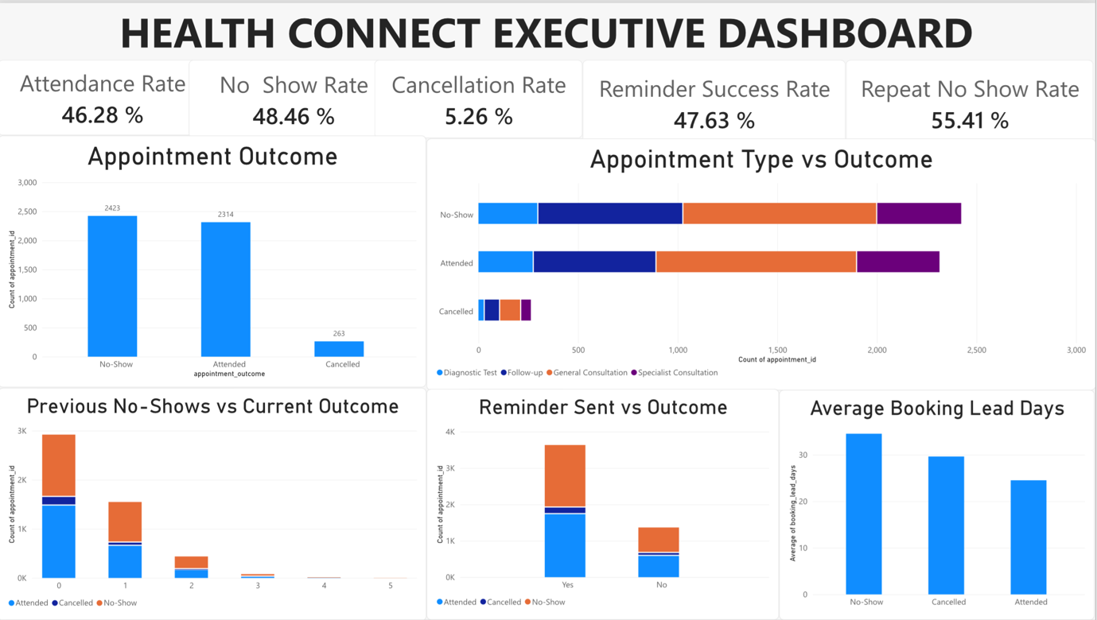

6. WHAT THE DATA SHOWS
A few key patterns emerged from the analysis.

Insight 1
Patients who'd missed appointments before were far more likely to miss again with no-show rates increasing from 43.5% among patients with no previous no-shows to nearly 68% among patients with three previous no-shows. The more previous no-shows someone had, the higher their no-show rate climbed, which is a strong signal that past behaviour is a good predictor of future attendance.
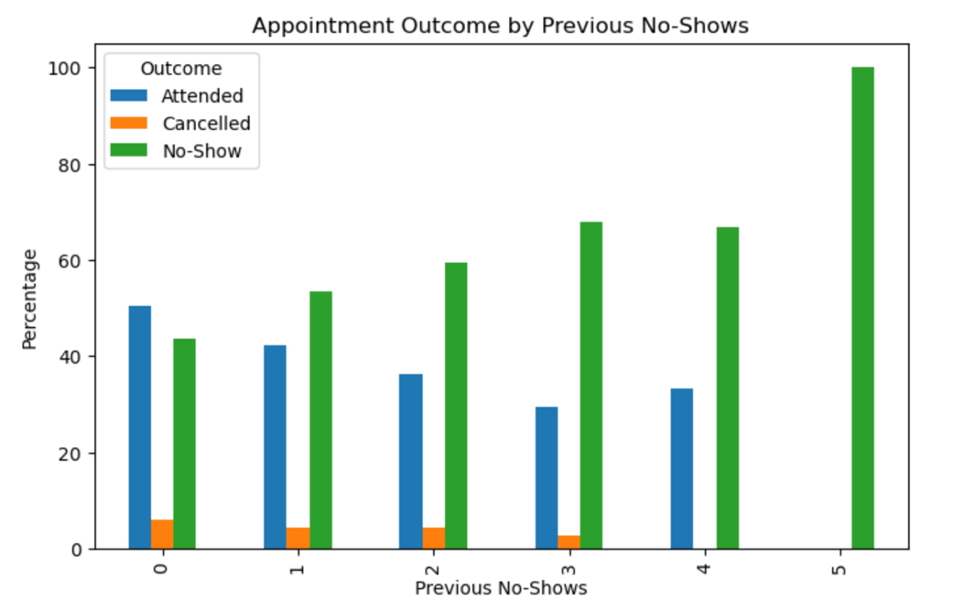

Insight 2
Appointments booked well in advance tended to have higher no-show rates. On average, patients who missed their appointment had booked it about ten days earlier than those who showed up. Patients who attended booked approximately 25 days in advance on average, whereas patients who missed appointments booked approximately 35 days in advance.

Insight 3
Patients who received a reminder attended slightly more often and missed slightly less often than those who didn't. It's not a dramatic effect, but it does suggest reminders are pulling some weight.
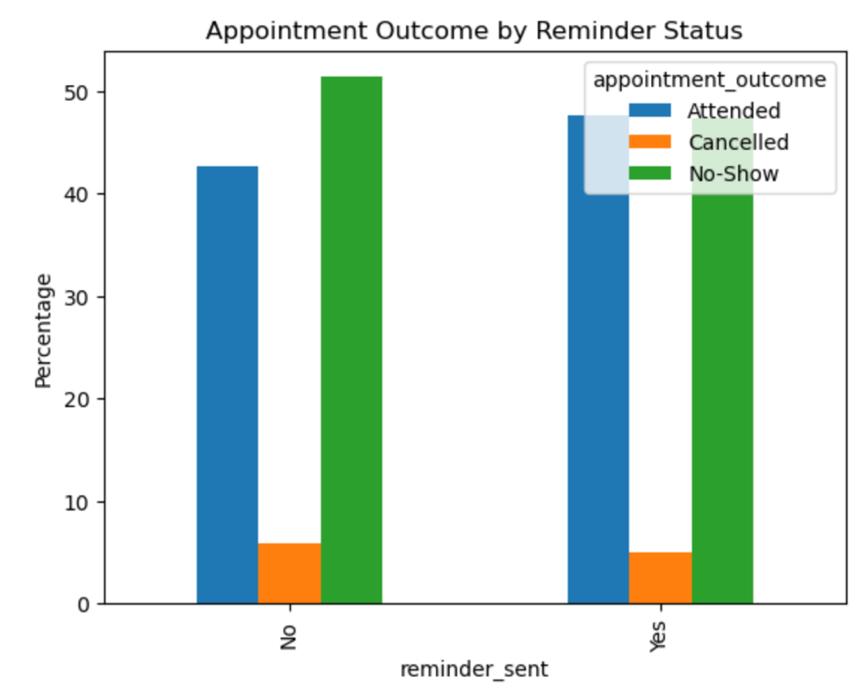

Insight 4
No-show rates stayed high across the board, regardless of appointment type. Ranging from approximately 46% to 51%, shoowing that this isn't a problem tied to one particular service. it's affecting the clinic as a whole.

Insight 5
Age, waiting time, and distance to the clinic didn't vary much between patients who showed up and those who didn't. On their own, these factors don't seem to explain much of what's driving no-shows.
These insights can help guide feature selection and model development for predicting appointment no-shows.

7. RECOMMENDATIONS
Based on all of this, here's what seems worth pursuing:
- Build out stronger reminder strategies specifically for appointments booked far in advance.
- Introduce enhanced reminder or confirmation procedures for appointments booked well in advance.
- Flag patients with a history of no-shows and put extra confirmation steps in place for them.
- Keep tracking attendance KPIs through an ongoing dashboard.
- Look into factors the current dataset doesn't cover. So things like appointment cost, staffing levels, and patients' socioeconomic circumstances.
- Compare reminder channels to see which ones actually move the needle on attendance.

8. ASSUMPTIONS, LIMITATIONS, RISKS AND DEPENDENCIES

Assumptions
- The dataset is a reasonably accurate reflection of HealthConnect's appointment records.
- Appointment outcomes were recorded correctly.
- Both cancellations and no-shows count as missed appointments operationally, but the focus here is on no-shows specifically, since cancellations at least give the clinic a chance to reassign the slot.

Limitations
- The dataset itself is fictional.
- Some potentially important variables like cost, staffing, socioeconomic background, just aren't available.
- The gaps in reminder channel data make it harder to fully judge how effective reminders really are.

Risks
- What we're seeing here are associations, not proven causes.
- Any gaps or inaccuracies in the data could be skewing the results.

Dependencies
- Ongoing access to the dataset and data dictionary.
- Continued collaboration with other tracks, especially for the predictive modelling work ahead.

9. WRAPPING UP
Week 5 marked the shift from planning into actually doing the work. Between the exploratory analysis, the KPIs, and the dashboard, we now have a much clearer picture of what's behind appointment attendance and no-shows.
Previous no-show history, how far in advance appointments are booked, and whether reminders go out all seem to matter and that gives us a solid base to build on when predictive modelling starts in Week 6.

